PROJECT PROPOSAL

NIHVA TECHNOLOGIES PVT. LTD.
187, G-Block, Thermax chowk, Above Renault Showroom, MIDC
Chinchwad, Pune – 411019.

CUSTOMER NAME | ORDNANCE FACTORY DEHUROAD
OFFICE ADDRESS | ORDNANCE FACTORY, DEHU ROAD, MAHARASHTRA 412101
PROJECT LOCATION | ORDNANCE FACTORY DEHUROAD
CONTACT PERSON NAME | MR. T.K PANDA  ENGINEERING HEAD
EMAIL ID | ofdreo.ofb@nic.in
CONTACT NUMBER | +91 9422009885

Contact Person: Mr. Mayur Derle
Mob No.: 7709209333
Web: http://www.nihva.com

AUTOMATION SOLUTION-DIVISION

Ordnance Factory

Title: Augmenting Charges Filler Machine

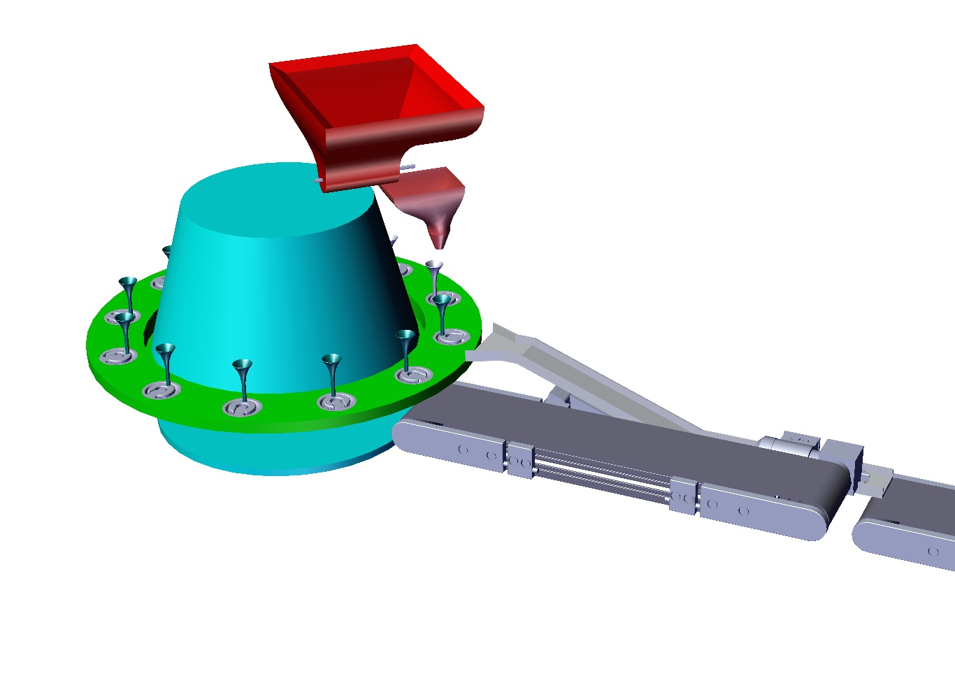

Contents
A. Requirement: - 4
B. NIHVA Scope of work: - 5
C. Drawing Training & Warranty: - 6
1.Training: - 6
2.Warranty: - 6
3.Maintenance & Service Agreement: 6
D. Details of Application: - 7
Components Details 7
❖ Type 1 7
❖ Type 2 7
User Requirement Details: - 8
NIHVA Machine Operation Sequence: - 8
E. Technical Specification: 9
PLC & HMI 9
Motor 1HP/ 2HP, Flameproof 9
Main Hopper screw motor 9
Bowl Feeders & Linear Feeders (As per requirements) 10
Conveyor system (As per requirement) 10
Pneumatic Cylinder 10
F. Commercial: 11
Augmenting Filler Machine 11
Safety features 12
G. Terms and Conditions: - 13

Date: 11.09.2017

To,

Ordnance Factory
Dehuroad, Pune-412101

Kind Attention: Mr. T.K. PANDA

Dear Sir,

Thank you for giving us an opportunity to participate with our offer on the above project.
We enclose here with our proposal includes: -

- Requirement
- Scope of Works
- Drawing, Training & warranty
- Details of Application
- Technical Specification
- Commercial
- Terms & conditions

A. Requirement: -

- Energy efficient Design: The system should be energy efficient. The design shall ensure minimum possible power.

- Reduced Manpower: In this process only few things are done by workers and all the heavy operation will have done by machine automatically. So, this system will require minimum labor work.

B. NIHVA Scope of work: -

The scope of work shall be exclusively on Augmenting Filler Machine.

For the above scope, following set of activities are expected to be performed:

NIHVA Automation Services Scope of supply Includes following: -

- Design

- Manufacturing

- Successful Trails at our end

- Dispatch at your ends.

- Installation & Commissioning @ ORDNANCE FACTORY DEHURAOD

- Operator & Maintenance Training.

- Warranty of the equipment for 1 year from commissioning date.

- Hard & Soft Copy of Operator & Maintenance Manual.

C. Drawing Training & Warranty: -

We will issue a full set of shop drawings for approval within 2 weeks of receiving the confirmed order and finalized design details.

1.Training: -

After installation of the automation system, we will train the Clients personnel in the operation and basic maintenance, including the understanding of the error codes on the control system (if applicable).

2.Warranty: -

The warranty period is twelve months from the date of installation and commissioning.
If a defect arises within the warranty period stated, which is attributable to faulty design, materials or installation workmanship the product will be repaired at our discretion without charge. This guarantee is subject to proper use of the product and assumes that the product is regularly serviced and maintained by skilled personnel in accordance with the operation and maintenance instructions supplied.

3.Maintenance & Service Agreement:

We would suggest that you take advantage of a maintenance and service agreement on the NIHVA products, which will guarantee trouble free operation and speed of response in an emergency. Customized proposals are available on request

D. Details of Application: -

Components Details

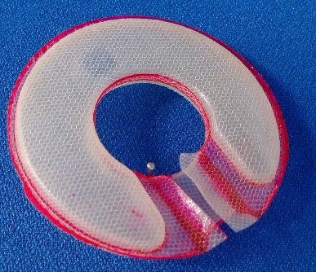

Type 1

- Work piece Description: - Augmenting Container
- Weight: - 12 grams approx.
- Diameter: - 81 mm
- Tolerance: - 50 milligram

1Concept Image of Augmenting Charge

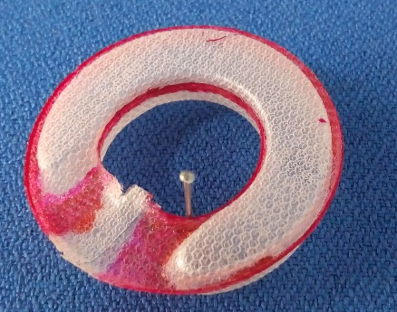

Type 2

- Work piece Description: - Augmenting Container
- Weight: - 2 grams approx.
- Diameter: - 51 mm
- Tolerance: - 50 milligram

2Concept Image of Augmenting Charge

User Requirement Details: -

- The system should be energy efficient. The design shall ensure minimum possible power.

- The automation for the system should ensure maximum productivity by using automatic system so that it will reduced human work and maximum number of charges will filled automatically.

NIHVA Machine Operation Sequence: -

- First augmenting Charges will load into the magazine unit.

- Then load all the flakes into the main hopper.

- After that flakes are passed to the weighing hopper by means of screw arrangement.

- When weighing hopper will indicate 12g of weight then it will transfer to filling Hopper by the action of pneumatic cylinder.

- Simultaneously the augmenting charges will feed to the conveyor & then to the linear feeder

- Linear feeder will feed all the charges one by one on rotary table and then filling hopper will fill all flakes into the charges.

- After that all the filled charges will pass out through linear feeder and then through conveyor.

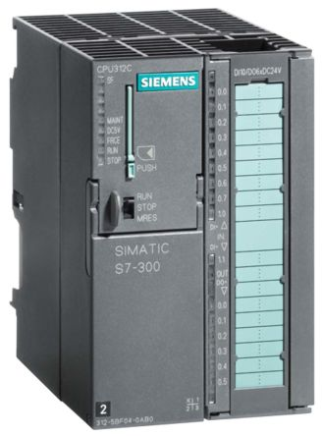
E. Technical Specification:

PLC & HMI
Make – Delta & Siemens

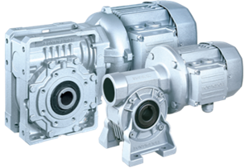

Motor 1HP/ 2HP, Flameproof
Geared Motors
Make – Crompton/Bonfiglioli

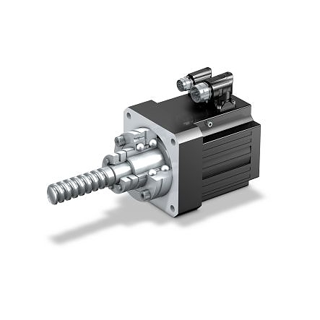

Main Hopper screw motor
(steeper, flameproof with machinal break)
Make – NEFA / NEMA

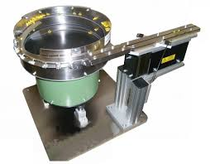
Bowl Feeders & Linear Feeders (As per requirements)
Make – NIHVA

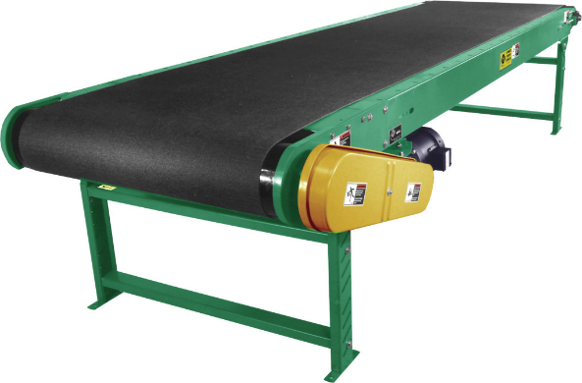
Conveyor system (As per requirement)
Make – NIHVA

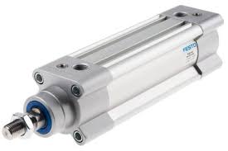
Pneumatic Cylinder
Make -- SMC & FESTO

F. Commercial:

Augmenting Filler Machine

Sr. No | Description | Qty | Price in  INR/Each | Total Amount  In INR
1. | Conveyors | 1 SET | 42,80,000 | 42,80,000
2. | Vibro-Platform | 1 SET | 42,80,000 | 42,80,000
3. | PLC & Sensors | 1 SET | 42,80,000 | 42,80,000
4 | Weighing Hoppers | 1 SET | 42,80,000 | 42,80,000
5. | Main Hopper & Extruder | 1 SET | 42,80,000 | 42,80,000
6. | Bowl Feeders & Linear Feeders System | 1 SET | 42,80,000 | 42,80,000
7. | Fabrication Assembly | 1 SET | 42,80,000 | 42,80,000
8. | Indexing Table Assembly | 1 SET | 42,80,000 | 42,80,000
9. | Installation Charges | 1 | 15,000 | 15,000
10. | Transportation Charges | 1 | 2,000 | 2,000
 | Total Amount |  |  | 42,97,000

Safety features

- In case of sudden power cut off, system will stand as it is until reset.

- FEA will be conducted for critical elements.

- All units are manufactured considering to work in explosive environment.

- In case of power failure system stop at where they are & resumes on power continuation.

- All vibratory elements are coated with PU Enamel Paint to avoid friction heat.

- Electrical power & signals are transferred through IP 68 rotary enclosure.

- Test Certificate will be provided for whole system.

G. Terms and Conditions: -

- Price : Ex. Works Pune

- P & F : Included in above prices.

- Freight Notes : Included in above price.

- Delivery : Within 9- 10 weeks from date of receipt of
confirmed purchase order, advance payment, drawing approval.

- Payment Terms : 80% advance along with confirmed purchase
order balance before dispatch.

- Insurance : Extra as applicable.

- GST : 28% Applicable on total supply value.

- Validity : 15 days from date of quotation.

9.Warranty : 12 months from date of supply.

Please feel free to contact Mr. Mayur Derle on 7709209333 for any further clarification in this concern.

With Best Regards,
Pooja Badre
7709209333
NIHVA Technologies Pvt Ltd

